Artificial Intelligence & Robotics, B.A.T.
ITAI 1371
Spring 2026
Instructor: Dr. Sina Nazifi
Author: Rich Fox
May 10, 2026

AI Usage
Claude
Used to code processes that I did not know how to code correctly, for example combining 3 models together and having a user input process.
Used for addressing any errors that came up, and there were plenty of those. One main one was Memory Issue
The Memory Error is happening because Pandas is trying to create a massive "dense" matrix. The dataset has about 84,000 movies and 200,000 users—multiplying those together creates a table with 16.9 billion cells. At 8 bytes per cell, that requires 126 GB of RAM, which is why the computer crashed. To fix this, I need to filter out the "noise" (movies and users with very few ratings) and use a Sparse Matrix that only stores the actual ratings, not the zeros.
Most of those 84,000 movies have only 1 or 2 ratings. They don't help the model much and take up 99% of the memory. By focusing on "popular" movies (50+ ratings), you likely drop from 84,000 rows to just a few thousand.

Model Performance Improvements
Several targeted optimizations were applied to improve both the accuracy and fairness of the recommendation system.
SVD Reconstruction Order The initial SVD implementation used scipy.sparse.linalg.svds(), which returns singular values in ascending order rather than descending. This caused the matrix reconstruction (U × Σ × Vᵀ) to prioritize the least significant latent factors instead of the most significant ones, producing effectively random rating predictions and an RMSE of ~2.81. Sorting the singular values descending before reconstruction brought SVD RMSE in line with expected performance.
User Bias Correction via Mean-Centering Users have fundamentally different rating styles — some never rate above 3.5 stars while others give 4+ stars routinely. Without correction, the model misreads these signals: a strict user's 3.0 (which may be genuine enthusiasm) looks identical to a generous user's 3.0 (which may indicate mild disappointment). To fix this, each user's mean rating was computed from the training set only and subtracted from all their ratings before model training. This ensures the models learn relative preference — whether a user liked a movie more or less than they typically do — rather than absolute star values. Predictions are de-centered back to real star values before computing RMSE and MAE so results remain interpretable.
Per-User Precision@K Threshold The original Precision@K metric used a fixed global threshold of 4.0 stars to define a "liked" movie. This unfairly penalized strict raters — a user whose average is 2.8 might consider a 3.2 a strong endorsement, but the global threshold would never count it. The threshold was replaced with each user's personal mean rating from the training set, so a recommendation is considered relevant if the user rated it above their own average. This makes Precision@K a consistent measure of preference across all user types.
Evaluation Sampling and Precomputed Matrices The original evaluation loop called kneighbors() and cosine_similarity() inside nested loops for every user and every movie, resulting in runtimes exceeding 90 minutes. This was replaced with fully precomputed prediction and similarity matrices built once before evaluation, reducing the bottleneck from repeated model calls to simple array lookups. User sampling (1,500 users for KNN/SVD, 500 for Hybrid) was added to further bound runtime while preserving statistical reliability, bringing total evaluation time down to approximately 2 minutes.

NotepadLM
Created md files for GitHub.
Used to verify all requirements were met.

Code Logic Diagram

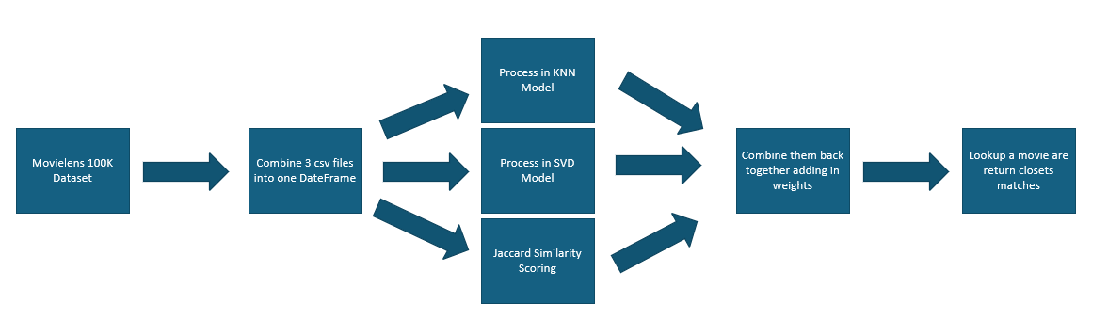

Your Data
Data needs to be downloaded from this link and extracted locally to C:\Data
https://drive.google.com/file/d/1KrVqseSE4WJLCKradCxNC9Ksg0rsl-yH/view?usp=sharing

